**Double- ended queue or D-queue**

In linear queue, insertion of elements we use one end called rear and for the deletion of elements, we use other end called as a front. But in the double- ended queue or D-queue insertion and deletion operations are performed from both the ends. That means it is possible to insert the elements by rear as well as by the front. Similarly, it is possible to delete the elements from the front as well as from the rear.

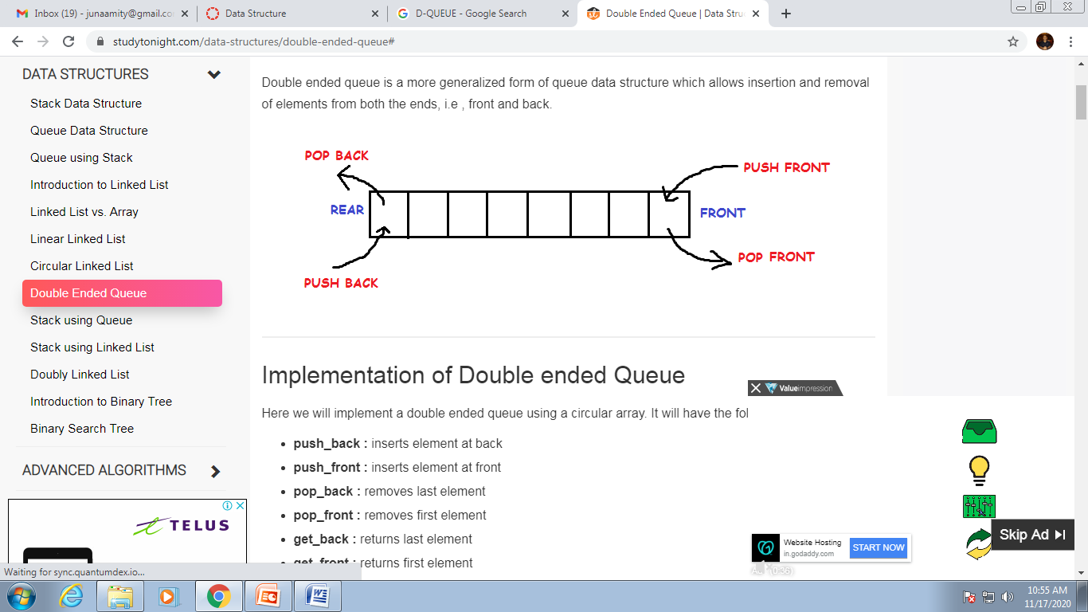

Here we will implement a double ended queue using a circular array. It will have the following methods:

**push_back :** inserts element at back

**push_front :** inserts element at front

**pop_back :** removes last element

**pop_front :** removes first element

**get_back :** returns last element

**get_front :** returns first element

**empty :** returns true if queue is empty

**full :** returns true if queue is full

**Input restricted D-Queue**: Input-restricted D-queue allows insertion of an element at only one end, but it allows the deletion of an element at both of the ends.

**Output-restricted D-queue:** Output-restricted D-queue allows deletion of the element at only one end, but it allows the insertion of an element at both the ends.

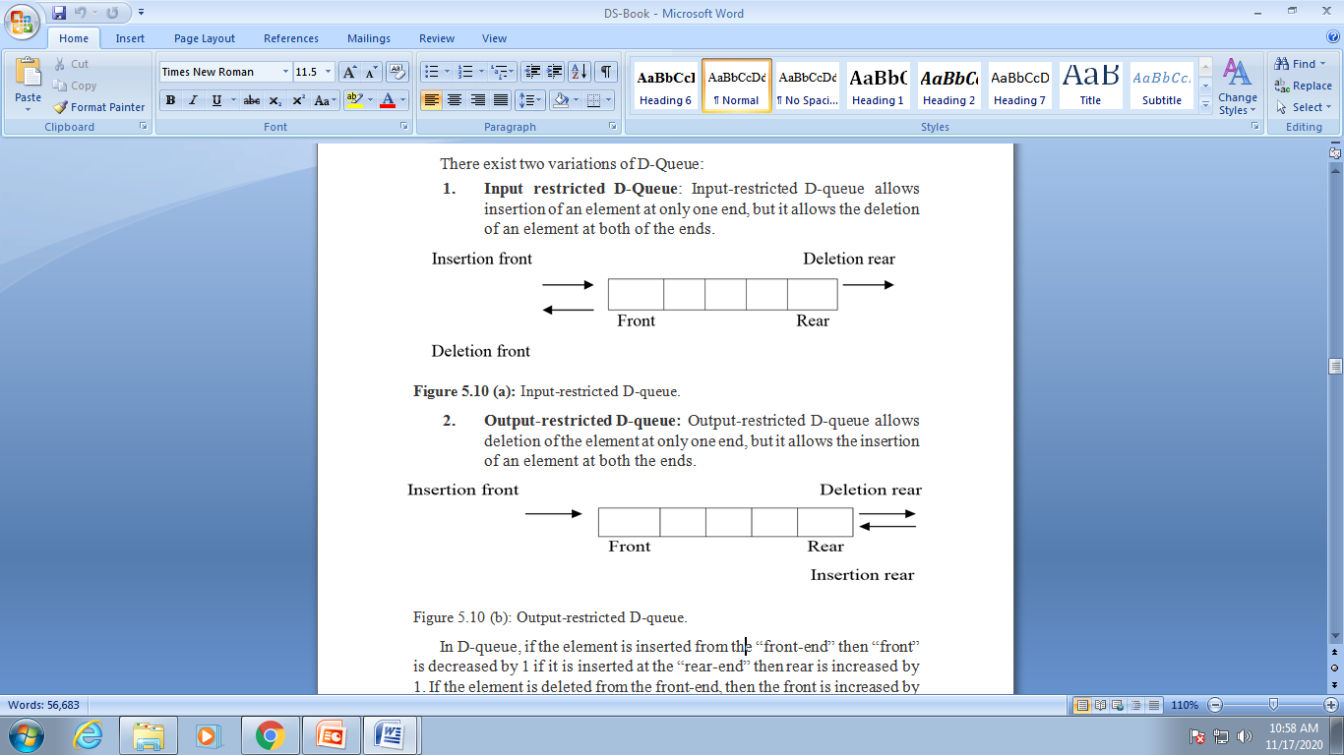

**PRIORITY QUEUE**

The priority queue is a data structure having a collection of elements which are associated with specific ordering. There are two types of priority queues-

**• Ascending priority queue –** it is a collection of items in which the items can be inserted arbitrarily but the only smallest element can be removed.

**• Descending priority queue –** it is a collection of items in which the items can be inserted arbitrarily, but the only largest element can be removed. In a priority queue, the elements are arranged in any order an out of which only the smallest or largest element allowed to delete each time.

Various operations of priority queue

Create () – The queue is created by declaring the data structure for it.

Insert () – The element can be inserted in the queue.

Delete () – if the priority queue is ascending priority queue then the only smallest element is deleted each time.

Display () – The elements of the queue are displayed from front to rear.